Chinese Lunar NewYear

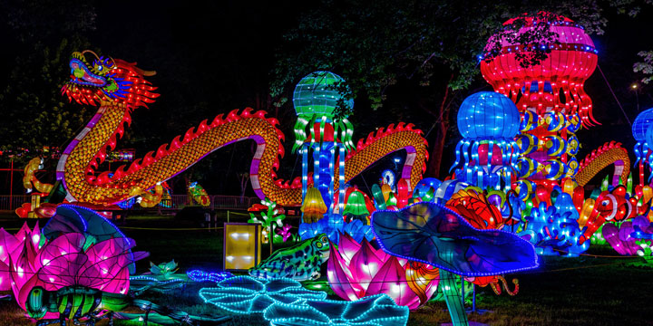

The origin of the Spring Festival now is too old to be traced. It is widely believed that the word ‘Nian'(in Chinese means 'year'), was first the name of a monster beast that started to prey on human being at the night before the beginning of a new year. It had a very big mouth that would swallow many people with one bite. People were very scared. One day, an old man came to their rescue, offering to subdue ‘Nian'. He said to ‘Nian' that ‘I hear that you are quite capable, but can you swallow other beasts on earth instead of people who are by no means of your worthy opponents?' Hence, ‘Nian' did swallow many of the beasts of prey on earth that also harassed people and their domestic animals from time to time. After that, the old man who turned out to be an immoral fairy disappeared riding the beast ‘Nian'. Now that ‘Nian' had gone and other beasts of prey are scared off into the forests, people began to enjoy their life in peace and happiness. Before the old man left, he had told people to put up red paper decorations on their windows and doors at each year's end to scare away ‘Nian' in case it sneaked back again, because red is the color that the beast feared most.

From then on, the tradition of observing the conquest of ‘Nian' is carried on from generation to generation. The term ‘Guo Nian', which may mean ‘Survive the Nian' becomes today's ‘Celebrate the New Year', as the word ‘Guo' in Chinese having both the meaning of ‘pass-over' and ‘observe'. The custom of putting up red paper and firing firecrackers to scare away 'Nian' had been well preserved

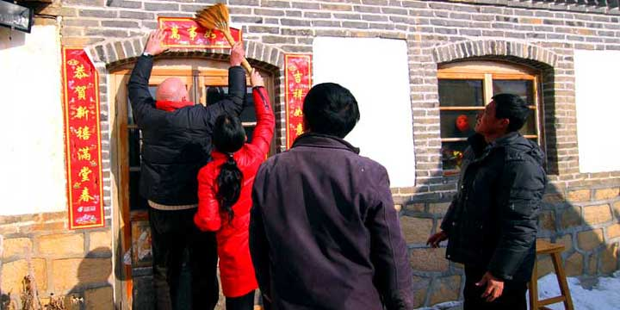

Equal to Christmas of the West in significance, the Spring Festival is the most important holiday in China. Two features distinguish it from the other festivals. One is seeing off the old year and greeting the new. The other is family reunion.

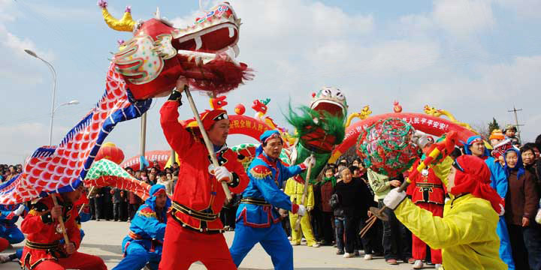

Two weeks before the festival the whole country is permeated with a holiday atmosphere. On the 8th day of the twelfth lunar month, many families will make the Laba Congee, a kind of congee made from more than eight treasures, including the glutinous rice, lotus seed, beans, gingko, millet and so on. Shops and streets are beautifully decorated and every household is busy at shopping and preparing for the festival. In the past, all families would make a throughout house cleaning, settling accounts and clearing off debts, by which to pass the year.

Paste couplets(Chinese: 贴春联): it’s a kind of literature. Chinese people like to write some dual and concise words on red paper to express their new year’s wishes. On the arrival of New Year, every family will paste couplets.

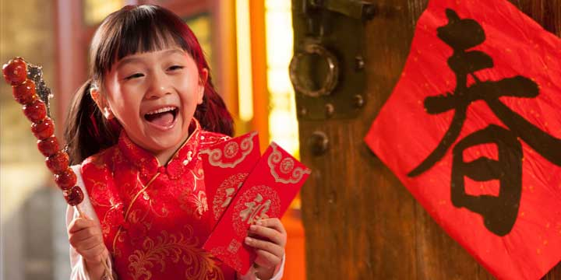

Family reunion dinner(Chinese: 团圆饭): people travelling or residing in a place far away from home will back to their home to get together with their families.  
Stay up late on New Year’s Eve(Chinese: 守岁): it’s a kind of way for Chinese people to welcome New Year’s arrival. Staying up late on New Year’s Eve is endowed with auspicious meaning by people. The old do it for cherishing their past time, the young do it for their parents’ longevity.  
Hand out red packets(Chinese: 发红包): elders will put some money into red packets, and then hand out to the younger generation during spring festival. In recent years, electric red packets are popular among younger generation.  
Set off firecrackers: Chinese people think the loud sound of the firecrackers can drive away devils, and the fire of the firecrackers can make their life thriving in the coming year.

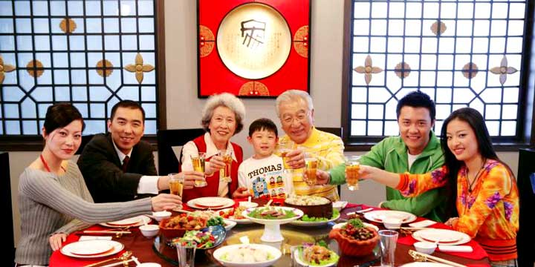  
  
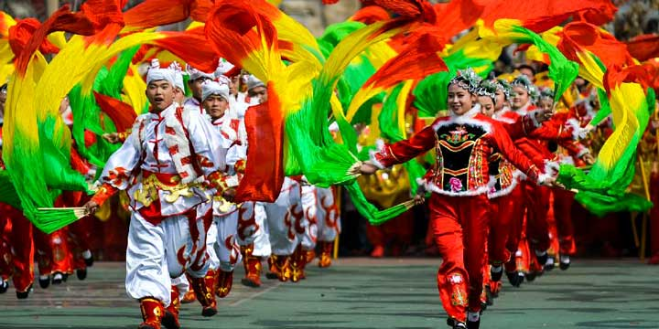

After dinner, people sit together before the TV to watch the New Year's program and chat with each other. About ten minutes before the ringing of the New Year's bell, people let out the fireworks to welcome back the Kitchen God from the Heaven, who is in charge of the fortune and misfortune of the household he dwells.



The custom of pasting couplets on the doors has a long history. In the ancient times, people hung short branches of peach tree on the doors or at the front gates for the purpose of driving away the evil things. Later they became peach wood boards with some Chinese characters written on them. With the invention of paper, on each of which was written a verse line to welcome the New Year to express wishes for happiness and good fortune. During the long time development, spring couplets have become a special form of literature with their own characteristic.

After putting up couplets and pictures in the doors on the Lunar New Year's Eve, the last day of the twelfth moon in the Chinese lunar calendar , each family gathers for a sumptuous meal called ‘family reunion dinner'. People will enjoy the food and drink in abundance and Jiaozi. The meal is more luxurious than usual. Dishes such as chicken, fish and bean curd is necessary, for in Chinese, their pronunciations sounds like ‘Ji', ‘Yu', and ‘Doufu', with the meanings of auspicious, abundant and rich. Sons and daughters working away from home come back to join their parents.

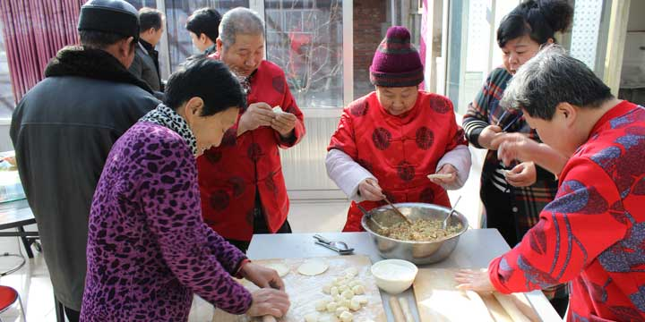

On the first three days of the festival, people will visit their close relatives and best friends, exchanging greetings and presents, which is known as the ‘New Year's Visit'. The young generation are given the red envelop from their elder generation. The Spring Festival carnivals take place during this period. There are performances of dragon dancing, lion dancing and recreational parades in the street by some troupes.  
On the second day, Chinese people pray to their ancestors as well as to all the gods.  
The third and fourth days, Married Women will come back to their parents' home with the husband and children to pay Spring Festival visits and extend New Year greetings  
The fifth day, Known as ‘Po Woo'. On the day people stay home to welcome the God of Wealth. No one visits relatives and friends on this day because it will bring both parts bad luck.

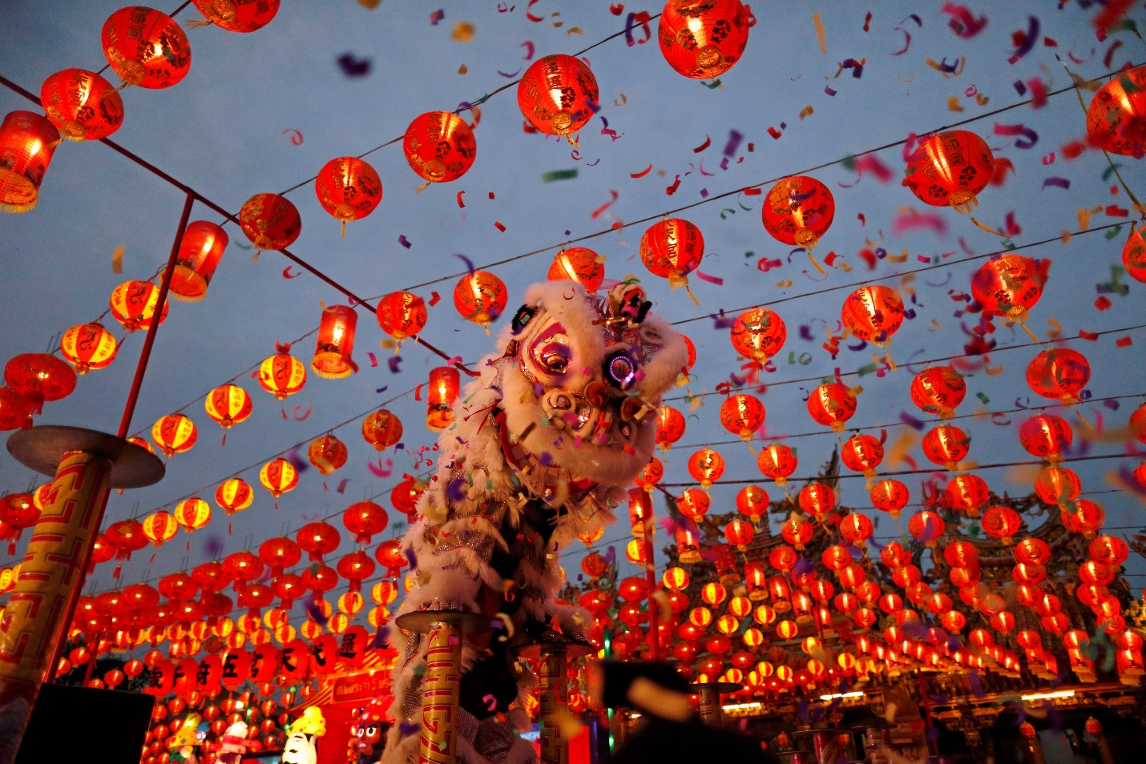

Two weeks before Spring Festival, people who are out of home for work start to come back to hometown from other cities by flight, train or bus to spend the festival with their festival. And usualy within two weeks after the festival, people will travel back to the cities in which they work. If you plan to visit China during Chinese New Year, in order to avoid tickets being sold out, you’d better book it in advance. Besides, the air fares will be more expensive than usual.